**Menoufia University**

**Faculty of Electronic Engineering**

**Embedded Systems(Lab.)**

**(LM35)**

**DEPARTMENT:**

* **Department of Engineering and Computer Science, 4rd year**

**STUDENT NAME:**

* **امجد مجدي فتحي سيد احمد**
* **سكشن (1)**
* **مجموعه (8)**

**Overview:**

**The LM35 is a precision integrated-circuit temperature sensor that provides an analog voltage output linearly proportional to the Celsius temperature. The LM35 thus has an advantage over linear temperature sensors calibrated in ˚ Kelvin, as the user is not required to subtract a large constant voltage from its output to obtain convenient Centigrade scaling. It's commonly used in various applications like temperature controllers, industrial systems, and consumer electronics for its simplicity and accuracy.**

**The LM35 series is available packaged in hermetic TO-46 transistor packages, while the LM35C, LM35CA, and LM35D are also available in the plastic TO-92 transistor package. The LM35D is also available in an 8-lead surface mount small outline package and a plastic TO-220 package.**

**The LM35C is rated for a −40˚ to +110˚C range (−10˚ with improved accuracy).**

**Temperature Range:**

**The LM35 can measure temperatures from -55°C to +150°C. This wide range makes it suitable for a variety of applications, from extreme cold to moderately high temperatures.**

**Output Voltage:**

**The output voltage of the LM35 increases linearly with temperature at the rate of 10mV per degree Celsius. This linear relationship simplifies interfacing with analog-to-digital converters (ADCs) or microcontrollers for temperature measurement.**

**Accuracy:**

**The LM35 has a typical accuracy of ±0.5°C at room temperature. This accuracy level is sufficient for many applications that require precise temperature monitoring.**

**Features:**

* **Calibrated directly in ˚ Celsius (Centigrade)**
* **Linear + 10.0 mV/˚C scale factor**
* **0.5˚C accuracy guaranteeable (at +25˚C)**
* **Rated for full −55˚ to +150˚C range**
* **Suitable for remote applications**
* **Low cost due to wafer-level trimming**
* **Operates from 4 to 30 volts**
* **Less than 60 µA current drain**
* **Low self-heating, 0.08˚C in still air**
* **Nonlinearity only ±1⁄4˚C typical**
* **Low impedance output, 0.1 Ω for 1 mA load**

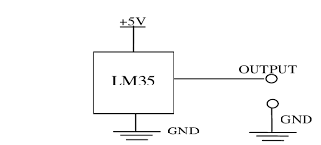**The LM35 can be connected as follows:**

* **Power Supply: Connect the Vcc pin to**

**a power supply voltage between 4V to 30V DC.**

* **Ground: Connect the GND pin to the ground of the circuit.**
* **Output: The output pin provides an analog voltage**

**that is linearly proportional to the temperature being sensed. Connect this pin to an analog input of a microcontroller or an ADC to measure the temperature.**

**Datasheet link:** [**https://www.ti.com/lit/ds/symlink/lm35.pdf**](https://www.ti.com/lit/ds/symlink/lm35.pdf)

**Task #4 (LM35)**

**In this task, we will measure the temperature using an LM35 module, and a communication serial will be used to display the results. The LED lighting intensity will also be controlled based on the change in temperature.**

**Required components for this lab:**

* **Breadboard**
* **Wires (male - male)**
* **1 Led**
* **1 resistor in range of 220Ω to 1KΩ.**
* **LM35**

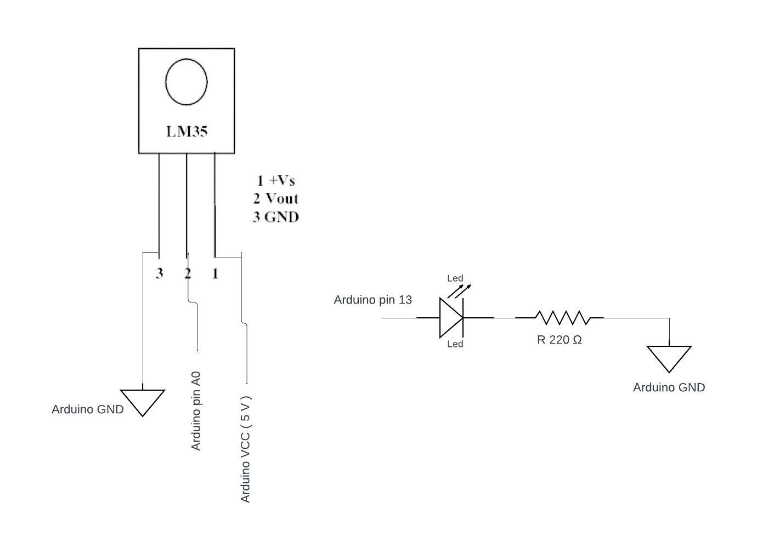**Circuit diagram**

**Code**

#define sensor  A0 // LM35 sensor connected to analog pin A0

#define led  13     // LED connected to digital pin 13 (PWM capable)

void setup() {

**Serial**.begin(9600); // Initialize serial communication

  pinMode(led, OUTPUT); // Set LED pin as output

  pinMode(sensor, INPUT); // Set sensor pin as input

}

void loop() {

  int sensorValue = analogRead(sensor); // Read analog value from LM35

  float voltage = sensorValue * (5.0 / 1023.0); // Convert analog value to voltage (0-5V)

  float temperature = voltage * 100.0; // Convert voltage to temperature in °C

  // Map temperature range (0-100°C) to PWM range (0-255)

  int brightness = ConvertTemperatureToPWM(temperature);

  analogWrite(led, brightness); // Set LED brightness using PWM

**Serial**.print("Analog Reading: ");

**Serial**.print(sensorValue);

**Serial**.print(", Output Voltage (V): ");

**Serial**.print(voltage);

**Serial**.print(", Temperature (°C): ");

**Serial**.println(temperature);

  delay(1000); // Delay for readability

}

int ConvertTemperatureToPWM(float temperature) {

  if (temperature <= 0) {

    return 0; // If temperature is below 0°C, set PWM to 0 (LED off)

  } else if (temperature >= 100) {

    return 255; // If temperature is above 100°C, set PWM to 255 (full brightness)

  } else {

    return int(temperature * 2.55); // Scale temperature linearly to PWM range (0-255)

  }

}

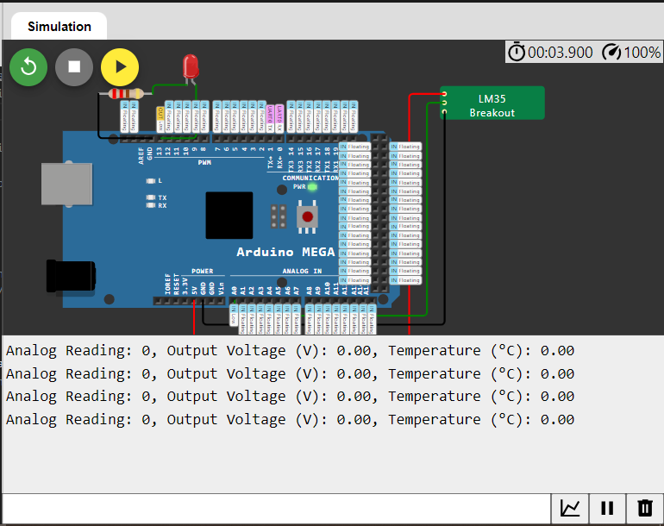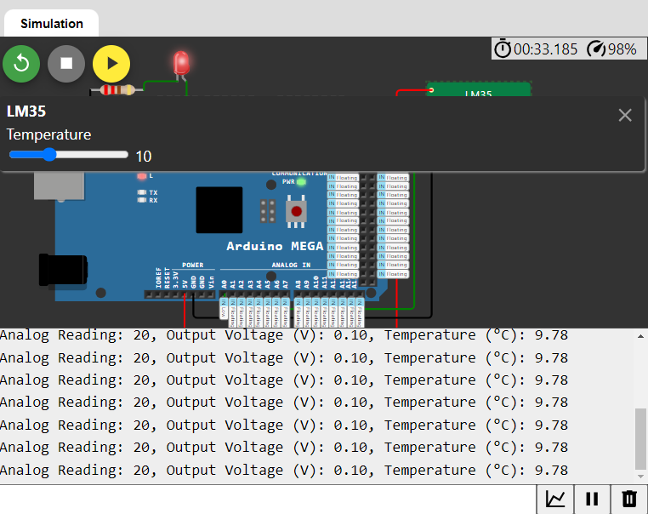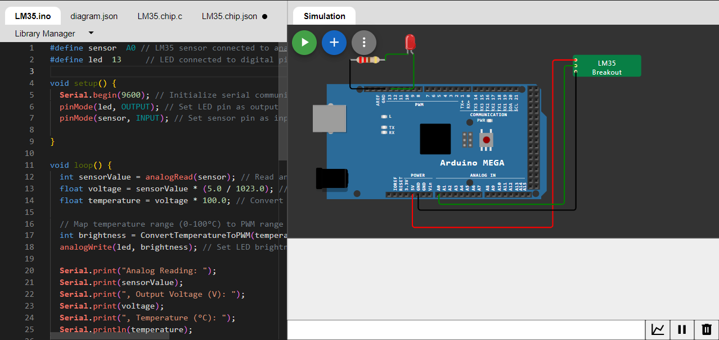**Simulation**

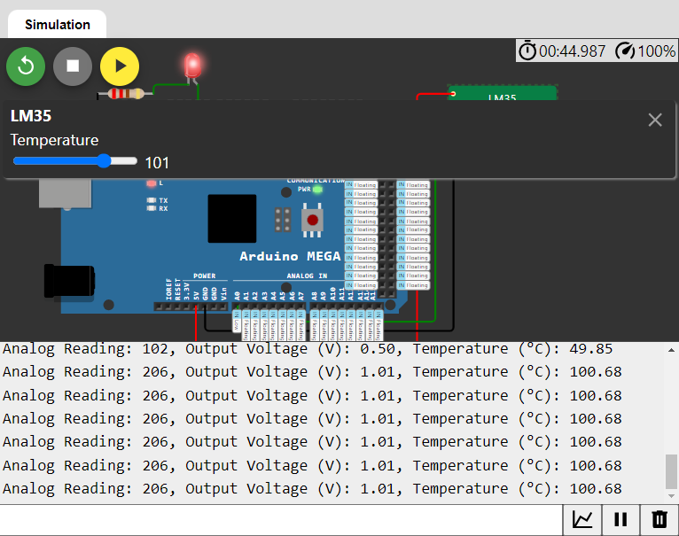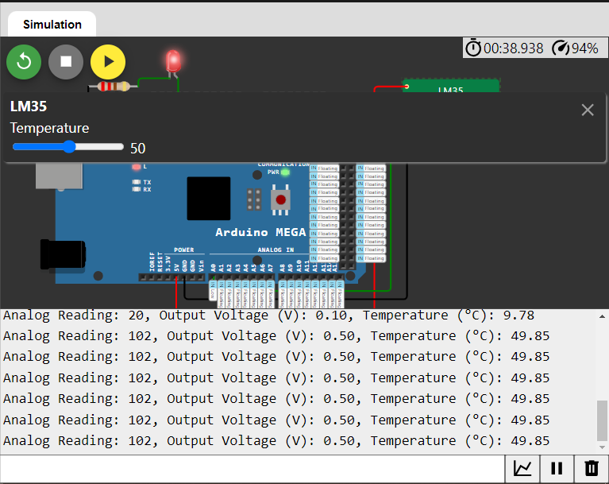



**My Simulation to run code:**

[**https://wokwi.com/projects/395155660245730305**](https://wokwi.com/projects/395155660245730305)

**Or Scan QR Code:**